1. **Binarisation Threshold:**

Feature vectors generated using height, radial, grayscale, density, line and vietoris-rips filtration and persistent entropy vectorization. Data was normalized before classification.

Training data: (50000, 52) and Test data: (10000, 52)

Classifier: Random Forest with number of trees = 1000 and random state = 31415

|  |  |  |
| --- | --- | --- |
| Binarizing threshold | Mismatch | Accuracy |
| 0.5 | 391 | 96.09 |
| 0.4 | 385 | 96.15 |
| 0.3 | 379 | 96.21 |
| 0.2 | 352 | 96.48 |

Images for different threshold:

**0.2 0.3**

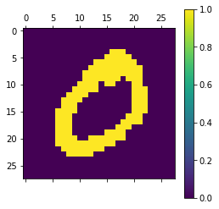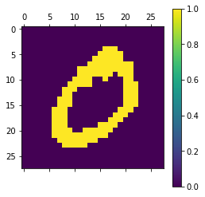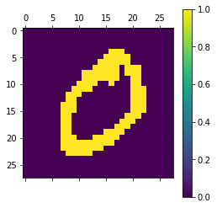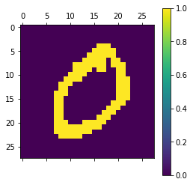

**0.4 0.5**

For a binarisation threshold of 0.2 the accuracy of classification with Random Forest Classifier for training with 60,000 images and testing on 10,000 images (without normalization) is **96.4.**

**2. Translated Images:**

**(6,3) (6, -3)**

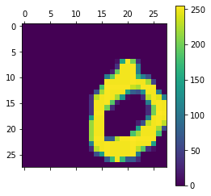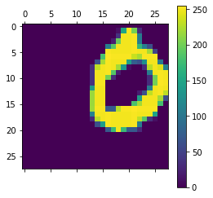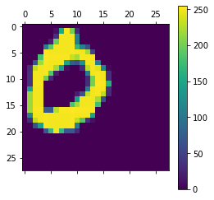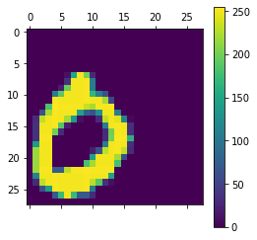

**(-6,3) (-6,-3)**

Feature vectors: Height, Radial, Grayscale, Density, Line and Vietoris-Rips filtrations and persistent entropy vectorisation

Training: (60000,52) ; No manipulation of images done on training dataset

Test: (3000, 52)

|  |  |  |
| --- | --- | --- |
| Test | Mismatch (/3000) | Accuracy |
| No change | 135 | 95.5 |
| Translation: (6,3) | 648 | 78.4 |
| Translation: (6,-3) | 633 | 78.9 |
| Translation: (-6,3) | 589 | 80.36667 |
| Translation: (-6,-3) | 577 | 80.76667 |

Examples of misclassifications on transforming image:

**classification : 9 classification: 9**

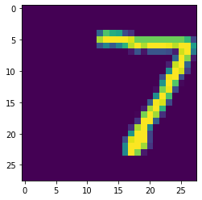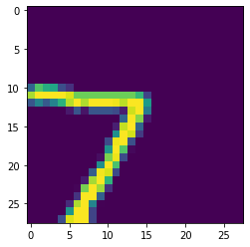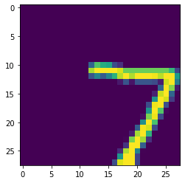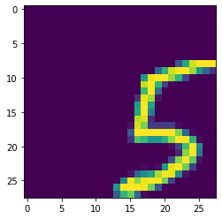

**classification: 9 classification: 2**

1. **Rotated Images:**

**0 30 60 90**

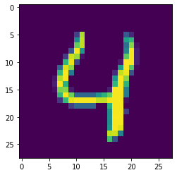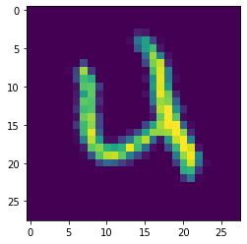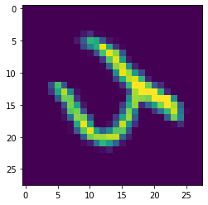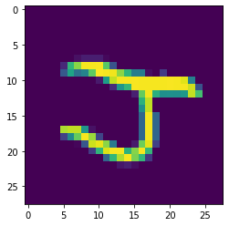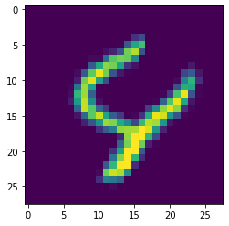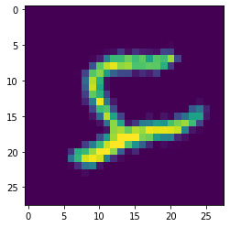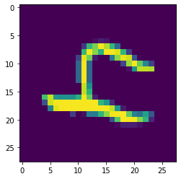

**-30 -60 -90**

Feature vectors: Height, Radial, Grayscale, Density, Line and Vietoris-Rips filtrations and persistent entropy vectorization.

Training: (60000,52) ; No manipulation of images done on training dataset

Test: (3000, 52)



Examples of misclassification on rotation of images:

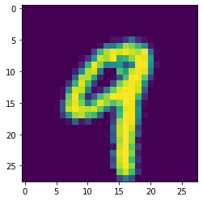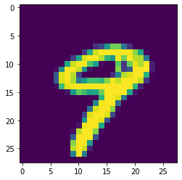

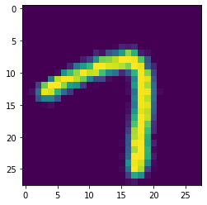 Angle = 0 ; classification: 9 Angle = 30; classification: 8

Angle = 30 ; classified: 9

1. **Classification using k-NN:**

Train Data: Binarisation threshold = 0.2 ; dim = (60000,52) ; Filtrations: Height, Radial, Grayscale, Density, Line, VR ; Vectorisation: Persistent Entropy. Data was normalized before performing UMAP.

Test: dim = (10000,52)

UMAP was performed on the data to reduce the dimension to 2. The accuracy of k-NN classification with k = 5 is **90.82**.

1. **Persistent Landscapes:**

Train Data: Binarisation threshold = 0.2 ; dim = (60000,50) ; Filtrations: Height, Radial, Grayscale, Density,Line ; Vectorisation: Persistent Landscape

Test: dim = (10000,50). Accuracy of classification using Random Forest Classifier with 1000 trees : **94.92**.

1. **Analysis with different vectorisations**

Train Data: Binarisation threshold = 0.2 ; dim = (60000,202) ;

Filtrations: Height, Radial, Grayscale, Density, Line Vectorisation: Persistent Landscape, Betti Curve, Persistent Entropy, Wasserstein.

Vietoris- Rips Vectorisation: Persistent Entropy

Test: dim = (10000,202).

Accuracy of classification using Random Forest Classifier with 1000 trees : **97.16**

1. **Translated Data**
2. **Rotated Data**

